Step -1 First we need to open **XAMPP** software and click on start the Apache after it go to the browser then search **localhost/dashboard**. If you are not getting any error that’s mean you are connected successfully( see the below image).

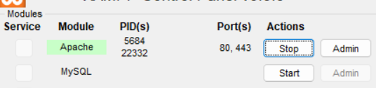

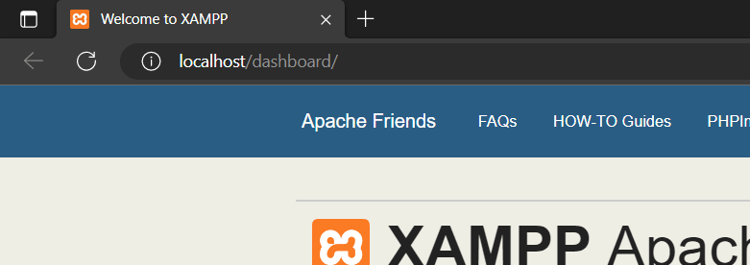

Step -2 Know search on browser **localhost/PHPProject/** (here P**HPProject** is my folder where I am store **.php** file see below image you get something like this and in this image you can see a file which name is Arithmetic Operator.php this is our php file ).

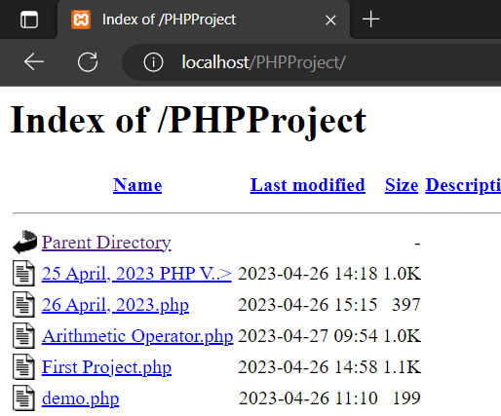

**Know we are performing our Activity’s.**

1. Write a program to add two numbers “10” and “5”.

Input:

<?php

            $a=10;

            $b=5;

            $c=$a+$b;

            echo "<h5>Addition of a=$a and b=$b is $c<h5>";

?>

Output:

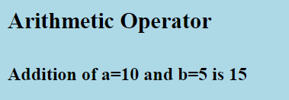

1. Write a program to subtract number “3” and “12”.

Input:

<?php

            $a=3;

            $b=12;

            $c=$a-$b;

            echo "<h5>Subtract of a=$a and b=$b is $c<h5>";

?>

Output:

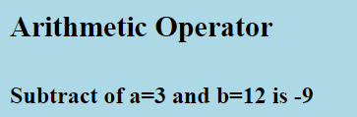

1. Write a program to subtract number “10” and “5”.

Input:

<?php

            $a=10;

            $b=5;

            $c=$a-$b;

            echo "<h5>Subtract of a=$a and b=$b is $c<h5>";

?>

Output:

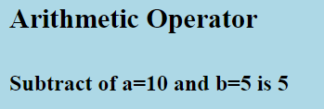

1. Write a program to multiply two numbers “7” and “11”.

Input:

<?php

$a=7;

            $b=11;

            $c=$a*$b;

            echo "<h5>Multiply of a=$a and b=$b is $c<h5>";

?>

Output:

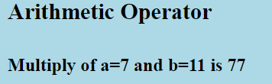

1. Write a program to divide “10” by “4” (10/4) and check the output.

Input:

<?php

$a=10;

            $b=4;

            $c=$a/$b;

            echo "<h5>Division of a=$a and b=$b is $c<h5>";

?>

Output:

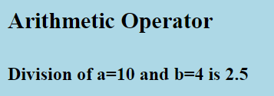

1. Write a program to check the reminder (using Modulus), when “10” divided by “4”.

Input:

<?php

$a=10;

            $b=4;

            $c=$a%$b;

            echo "<h5>Reminder of a=$a and b=$b is $c<h5>";

?>

Output:

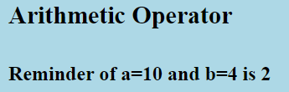

1. Show the output where output is(The Addition of two variables is this).

Input:

<?php

$a=10;

            $b=5;

            $c=$a+$b;

            echo "<h5>The Addition of Two variable is $c</h5>";

?>

Output:

